WORK SHEET - 4
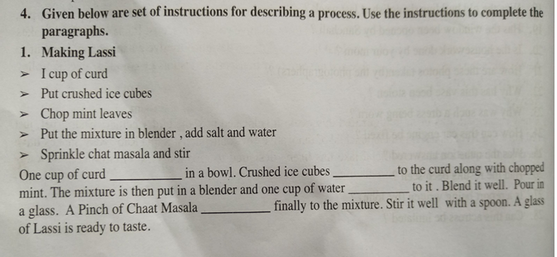
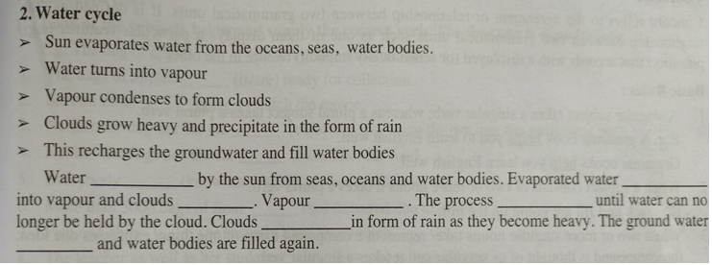
1) is poured, are added, is to be poured, will be added. 2) is evaporated, is turned, by condensation, condenses, is continued, precipitates will be recharged.

